Slattery, Alex Francis (mainly from International Forestry Students Association website)

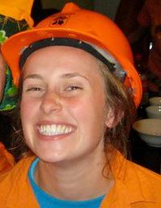

B Sc Forestry/Bachelor of ? Visual Arts ANU 2011. Attended the 39th International Forestry Students Symposium in Finland 3rd – 18th August 2011, her third Symposium. Spent 2010 studying abroad in Oregon, USA and was an International Forestry Students Association consulting member having been the Vice President 2009-2010.

Compliance and Environment Forester. Forestry Corporation of NSW, Macquarie Region 2013.

